Patient Name: _______________________________________________________ DOB: _______________
Employer Name: ___________________________________________________________________________
Address: __________________________________________________________________________________
Claim Number: ______________________________ Date of Injury/DOI: _____________________________
Description of Accident: _____________________________________________________________________

Adjuster’s Information
Adjuster’s Name: ___________________________________________________________________________
Adjuster’s Phone Number: ______________________________ Fax Number: _________________________

Workers’ Compensation Insurance Carrier Information
Company Name: ___________________________________________________________________________
Address: __________________________________________________________________________________
Phone Number: ___________________________________ Fax Number: _____________________________
Have you completed a Notice of Injury Form for your employer? Yes NO
Any person who knowingly and with intent to injure, defraud, or deceive any employer or employee, insurance company, or self-insured program, files a statement of claim containing any false or misleading information is guilty of felony of the third degree. In the event the illness or condition is not a result of Workers Compensation, I hereby agree to pay the fees for services rendered.

Patient Signature: ___________________________________________________ Date: _________________________

GENERAL PATIENT INFORMATION

Patient (FULL, LEGAL) Name: __________________________________________________________________
Date of Birth: _____ _____ _____ Social Security Number (required): _______________________________
Patient Gender: ________________ Marital Status: Single Married Divorced Widowed
Preferred Language: ________________ Have you ever been a patient in this practice before? Yes No
Ethnicity (select one): Hispanic/Latino Not Hispanic/Latino
Race: Black/African American American Indian Asian White Hawaiian/Pacific Island Other__________________
Home Address: _____________________________________________________________________________
Alternate Address (If applicable): _________________________________________________________________
E-Mail: ____________________________________ Home: ___________________ Cell: _________________
Emergency Contact: ________________________________________ Phone#: _________________________

Patient Signature: ___________________________________________________ Date: _________________________
**Please provide a brief explanation for today’s visit: _________________________________________________
Smoking Status: Former Never a smoker Current smoker, Packs per day___________
Have you had: Pneumonia Vaccine? No Yes, when? _________ Flu Vaccine? No Yes, when? _______
Review of Systems: Do you have any of problems related to the following systems? Check the appropriate box.
 | Yes | No |  | Yes | No
Fatigue |  |  | Abdominal Pain
Fever |  |  | Black or tarry stool
Chills |  |  | Bloody stool
Eyes watering or discharge |  |  | Urinary frequency
Loss of hearing |  |  | Urinary incontinence
Nasal passage blockage |  |  | Muscle weakness
Sore throat |  |  | Easy bruising
Chest pain or discomfort |  |  | Joint Pain, where____________
Palpitations |  |  | Dizziness
Feeling of the feet being cold |  |  | Fainting
Shortness of breath |  |  | Depression
Cough |  |  | Skin Lesion
Coughing up blood |  |  | Numbness or tingling in legs/feet
Nausea |  |  | Swelling in legs/feet
Vomiting |  |  | Other:

Family History: (please select all that apply)
 | Father | Mother | Brother | Sister
Breast Cancer
Ovarian Cancer
Other Cancer
Heart Disease
Stroke
Hypertension
Diabetes
Atherosclerotic Vascular Disease
Aneurysm
Other (please specify)

For nurse, only: BP________ HR ________ Temp ________ RR _______ Sat ________ Ht ________ Wt ________

Patient Signature: ___________________________________________________ Date: _________________________

Have you had any x-rays or tests to evaluate current problem? No Yes, please explain____________________
Have you had a similar problem before? Yes No If Yes, how long ago? ___________________________
Do you have pain related to your current problem? Yes No
If YES, pleas CONTINUE with questionnaire. If NO, please STOP and CONTINUE ON THE OTHER SIDE
Where is the pain? (mark an “X” on the diagram)

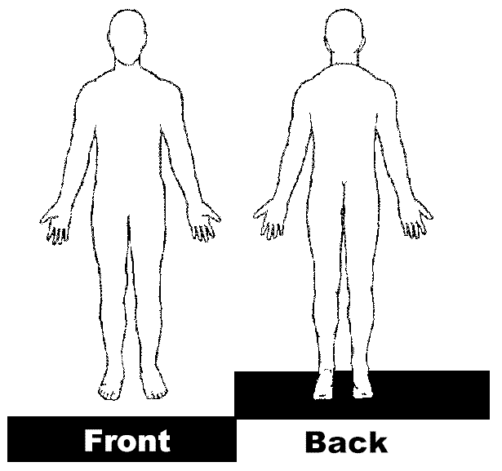
Describe your pain/symptoms: (check if applicable)
- Stays all the time
- Comes and goes
- Pressure
- Throbbing
- Numbness
- Aching
- Dull
- Sharp
- Heavy
- Burning
- Tingling
- Gnawing
- Shooting
- Pricking

Please, rate your pain/comfort level using the scale below:
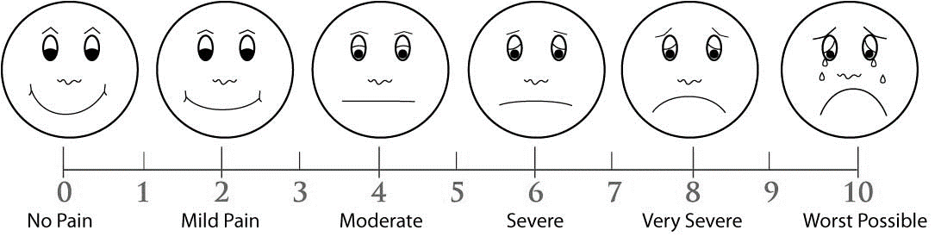
What is your goal for pain relief using above scale? ___________
What activities/positions increase your pain? _____________________________________________________________
What activities/positions decrease your pain? ____________________________________________________________
What activities does pain interfere with or prevent you from doing? __________________________________________
Patient Signature: ___________________________________________________ Date: _________________________
Allergies: None Latex Allergy: Yes No
Medication Allergies Reaction
__________________________________________________________________________________________________
__________________________________________________________________________________________________
__________________________________________________________________________________________________
__________________________________________________________________________________________________
Food Allergies: No Yes _______________________________________________________________
Dye/Tape Allergies: No Yes _______________________________________________________________
Shellfish/Iodine Allergies: No Yes ________________________________________________________

Current Medications: Check here if attaching a home medication list
Preferred Pharmacy: Name_____________________________ Phone Number: _______________________
Is this a mail-in pharmacy? Yes No
Medication | Dosage | Times per day | Prescribing Doctor

Patient Signature: ___________________________________________________ Date: _________________________
Social History: Advanced Directives (Living will): Yes No
Occupation: _________________________________ | Single Married Divorced Widowed
Alcohol: No Yes Drinks per day/week: ____________________________________________________________
Drug Use or Addiction: No Yes Drug(s): _____________ Caffeine use: No Yes How often? _________
Past Medical History: No Medical History | Check all that apply

- Aortic Aneurysm
- Carotid Artery Stenosis
- Stroke
- Peripheral Arterial Disease
- Varicose Veins
- Hypertension
- Heart Disease
- Intermittent Claudication
- Irregular heart beat
- Murmur
- Heart Attack (MI)
- Venous insufficiency
- Colitis
- Constipation
- Diverticulosis/Diverticulitis
- Gallbladder disease
- Esophageal reflux
- Gastrointestinal Bleeding
- Hernia: ______________
- Hemorrhoids
- Irritable Bowel Syndrome
- Intestinal obstruction
- Asthma
- COPD
- Chronic Kidney Disease
- Colon polyps
- Hematuria
- Kidney stones
- Depression
- Bipolar Disorder
- Anxiety
- Sleep Apnea
- Asthma
- Arthritis
- Fibromyalgia
- Diabetes Mellitus
- Neuropathy
- Hyperthyroidism
- Hypothyroidism
- Hepatitis
- HIV
- Tuberculosis
- Alzheimer’s Disease
- Chronic Pain
- Dementia
- Multiple Sclerosis
- Parkinson’s Disease
- Seizure Disorder
- Anemia
- Coagulation Defects
- Sickle Cell Disease
- DVT: _____________
- Pulmonary Embolism
- Cancer: ___________
- Other: ____________

Past Surgical History: No Surgical History | Please list surgeries and approximate date

- Aneurysm Repair
- Angioplasty
- Appendectomy
- Arthroscopy
- AV Graft/Fistula
- Brain Surgery
- Breast Biopsy
- Cataract Removal
- Cardiac Bypass
- Gallbladder Removal
- Heart Catherization
- Heart valve replacement
- Hemorrhoidectomy
- Hernia: ___________
- Hysterectomy
- Kidney Removal
- Mastectomy [ ] L [ ] R
- Pacemaker
- Implanted Defibrillator
- Prostate Surgery
- Spine (back/neck)
- Splenectomy
- Thyroid Surgery
- Tonsils/Adenoids
- Total Hip [ ] L [ ] R
- Total Knee [ ] L [ ] R
- Tubal Ligation
Other: _____________________
Other: _____________________
Other: _____________________

Patient Signature: ___________________________________________________ Date: _________________________
CONSENT TO DISCLOSE MEDICAL INFORMATION

Patient Name: __________________________________ SSN#: ______________________
I give my permission to Surgical Specialists of Southwest Florida, P.A., to disclose my protected health information to the following family or friends:

Name: _________________________________________ _ Relationship: __________________________
Name: _________________________________________ _ Relationship: __________________________
Name: _________________________________________ _ Relationship: __________________________

OR

I request that all my protected health information be disclosed only to “Me” and no one else other than my other healthcare providers.

May we leave a message on your answering machine/voice message about your medical care? Yes No
By signing this form, you are granting consent to Surgical Specialists of Southwest Florida to use and disclose your protected health information for purposes of treatment payment, and health care operations. I authorize the release of my medical records to any physicians to whom I am referred. I understand that I am financially responsible for all charges of services to me, including the balance remaining after payment of possible insurance benefits. I assign the benefits payable for physicians’ services to the physician furnishing the services.
Our Notice of Privacy Practices provides more detailed information about how we may use and disclose this protected health information. You have a legal right to review our Notice of Privacy Practices before you sign this consent, and we encourage you to read it in full. Our Notice of Privacy Practices is subject to change. If we change our notice, you may obtain a copy of the revised notice by calling our office at (239) 936-8555. You have a right to request us to restrict how we use and disclose your protected health information for the purposes of treatment, payment or health care operations. We are not required by law to grant your request. However, if we do decide to grant your request, we are bound by our agreement. You have the right to revoke this consent in writing, except to the extent we already have used or disclosed your protected health information in reliance on your consent. A copy of this form is to be considered valid as an original.

We utilize an automated system to remind you of your next appointment. By signing this you also give us permission to include you in this automated calling system. If you do not wish to be reminded of future appointments, please let the receptionist know this.

Patient Signature: ___________________________________________________ Date: _________________________
CONSENT FORM FOR ePRESCRIBE PROGRAM

ePrescribe Program
ePrescribing is way for doctors to send an accurate, error free, and understandable electronic prescription from the doctor’s office to the pharmacy. The ePrescribe Program also includes:

• Formulary and benefit transactions - Gives the health care provider information about which drugs are covered by your drug benefit plan.

• Medication history transactions - Provides the health care provider with information about your current and past prescriptions. This allows health care providers to be better informed about potential medication issues and to use that information to improve safety and quality. Medication history data can indicate: compliance with prescribed regimens; therapeutic interventions; drug-drug and drug-allergy interactions; adverse drug reactions; and duplicative therapy.

Consent
By signing this consent form, you are agreeing that your provider may request and use your prescription medication history from other healthcare providers and/or third party pharmacy benefit payors for treatment purposes.

You may decide not to sign this form. Your choice will not affect your ability to get medical care, payment for your medical care, or your medical care benefits. Your choice to give or to deny consent may not be the basis for denial of health services. You also have a right to receive a copy of this form after you have signed it.

This consent form will remain in effect until the day you revoke your consent. You may revoke this consent at any time in writing but if you do, it will not have an effect on any actions taken prior to receiving the revocation.

Understanding all of the above, I hereby provide informed consent to Surgical Specialists of Southwest Florida, PA to enroll me in this ePrescribe Program. I have had the chance to ask questions and all of my questions have been answered to my satisfaction.

________________________________________ __________________________
Print Patient Name Patient DOB

________________________________________ __________________________
Signature Patient Date

________________________________________
Relationship to Patient

